
MERIDIAN JUNIOR COLLEGE
JC2 Preliminary Examination

___________________________________________________________________
H1 Mathematics 8864
11 September

3 hours
Additional Materials: Writing paper
List of Formulae (MF 15)

___________________________________________________________________

READ THESE INSTRUCTIONS FIRST

Write your name and civics group on all the work you hand in.
Write in dark blue or black pen on both sides of the paper.
You may use a soft pencil for any diagrams or graphs.
Do not use staples, paper clips, highlighters, glue or correction fluid.

Answer all the questions.
Give non-exact numerical answers correct to 3 significant figures, or 1 decimal place in the case of angles in degrees, unless a different level of accuracy is specified in the question.

You are expected to use a graphic calculator.
Unsupported answers from a graphic calculator are allowed unless a question specifically states otherwise.
Where unsupported answers from a graphic calculator are not allowed in a question, you are required to present the mathematical steps using mathematical notations and not calculator commands.

You are reminded of the need for clear presentation in your answers.

The number of marks is given in brackets [ ] at the end of each question or part question.

At the end of the examination, fasten all your work securely together.

[Turn Over]

___________________________________________________________________

This document consists of 6 printed pages and 2 blank pages.
BLANK PAGE

Section A: Pure Mathematics [35 marks]

1 Find the range of values of p for which the equations 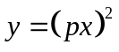and 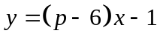 have real solutions. [4]

2 Find
(a) 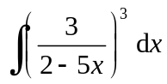 , [3]

(b) 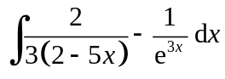. [3]

3 The diagram shows a rectangle ABCD inscribed in a semicircle with centre O and radius 5 cm. Given that AB is x cm, show that the perimeter L cm of the rectangle ABCD can be expressed as 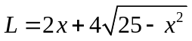.
Using differentiation, find the exact value of x when L is maximum. [6]


A
B
D
C
O
x

4 The curve C₁ has equation 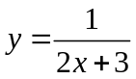. The curve C₂ has equation 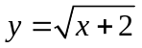.
(i) Sketch C₁ and C₂ on the same diagram, showing clearly the intersection(s) with the axes and the equation(s) of the asymptote. [4]

(ii) State the solution to the equation 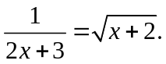 [1]

(iii) Find the exact area bounded by C₁, C₂ and the y-axis. [4]

[Turn Over

5 A curve C has the equation 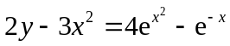.
(i) Show that 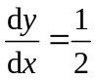 at . [4]

(ii) Hence find the equations of the tangent and normal at . [3]

(iii) The tangent and normal at meet the x-axis at P and Q respectively. By finding the coordinates of P and Q, find the length of PQ. [3]

Section B: Statistics [60 marks]

6 A particular school has 8 departments and a total of 300 staff. The number of staff in each department is different. The principal decides to survey a sample of 50 staff to seek their opinions on the school’s staff welfare. Simple random sampling and stratified sampling are suggested on how the sample can be selected.

(i) Describe how each method can be carried out. [4]

(ii) Give a possible reason why stratified sampling is preferred over simple random sampling. [1]

7 John plays a computer game which has 3 stages to be completed. He can only win or lose in each stage. From his past experience in playing the game, it is known that the probability of him winning in Stage 1 is 0.7. However, the probability of him winning the next 2 stages depends on the result of the preceding stage. The observation is as follows.

- The probability of him winning the next stage, given that he won the previous stage, is 0.8.
- The probability of him winning the next stage, given that he lost the previous stage, is 0.4.

One point is awarded for winning in a stage and one point is deducted for losing in a stage. To win the game, the total score must be positive.

Construct a probability tree diagram showing this information. [2]

Find

(i) the probability that he will attain a positive total score in a game, [2]

(ii) the probability that he will attain a negative total score in that game, given that he lost in Stage 1. [2]

8 The events A and B are independent. It is given that 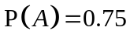and 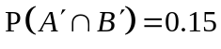. Find

(i) 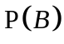, [3]

(ii) 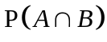. [1]

The events B and C are mutually exclusive such that 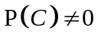. Given that C is a subset of A, find the range of possible values of 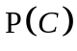. [2]

[Turn Over

9 Packets of a particular brand of orange juice are said to contain 300 ml each. A random sample of 100 packets is taken and the volume of liquid in each packet is measured. The volumes, x ml, are summarised by 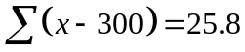 and 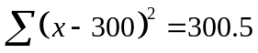.

(i) Find unbiased estimates of the population mean and variance. [3]

(ii) Test, at the 7% significance level, whether the population mean volume differs from 300ml. [4]

(iii) Explain, in the context of the question, the meaning of ‘at the 7% significance level’. [1]

(iv) Without carrying out further tests, explain whether the conclusion remains unchanged if the test had been for an increase in the mean at the 7% significance level. [2]

10 A large number of tickets are sold in a lottery. Each ticket can either win $5 or nothing. Each ticket has a constant probability of p of winning $5 and Charlie bought 45 tickets.

(i) State an assumption needed for the number of winning tickets bought by Charlie to be well modelled by a binomial distribution. [1]

(ii) Given that the probability that Charlie has less than one winning ticket is 0.003,
state an equation in terms of p and show that p = 0.121 (correct to 3 significant
figures). [3]

(iii) Find the probability that Charlie wins at most $25. [2]

(iv) Use a suitable approximation to find the probability that Charlie has more than 8 winning tickets. [4]

11 Lean Manufacturing Pte Ltd specializes in the production of microchips. The raw materials make up 15% of its total production cost for making microchips. Depending on the production quantity (q) required by the client, the total production cost ($C) are shown in the table below.

q | 100 | 200 | 300 | 400 | 500 | 600 | 700 | 800
C | 20 | 38 | 54 | 68 | 120 | 90 | 98 | 104

(i) Calculate the linear product moment correlation coefficient between q and C, and comment on the value found. [2]

(ii) Sketch the scatter diagram for the data. [2]

(iii) One of the pairs of data appears to be recorded wrongly. Indicate the corresponding point on your diagram by labeling it P, and explain why the scatter diagram for the remaining points may be consistent with a linear model. [2]

(iv) Omitting P, calculate the equation of a suitable least squares regression line, justifying the choice of the regression line. [2]

(v) Use the regression line found in part (iv), estimate the production quantity required by the client when the cost of the raw materials is $15. Comment on the reliability of the estimate. [3]

12 The mass of a papaya harvested in Plantation A is found to have mean 1.5 kg and standard deviation 0.15 kg. The mass of a papaya harvested in Plantation B is found to have mean 1.2 kg and standard deviation 0.2 kg. The masses of papayas from both plantations are independent. Papayas in both Plantations A and B are packed separately into baskets of 50 each.

(i) Find the probability that the difference between the mean mass of a papaya in a randomly chosen basket from Plantation A and the mean mass of a papaya in a randomly chosen basket from Plantation B is less than 0.2kg. [4]

(ii) Find the probability that a randomly chosen basket from Plantation A weighs less than 74 kg and a randomly chosen basket from Plantation B weighs more than 62 kg. [4]

(iii) The baskets of papayas from Plantation A and B are sold at $0.30 per kg and $0.40 per kg respectively. Find the probability that a randomly chosen basket from Plantation B is sold for a higher price than a randomly chosen basket from Plantation A. [4]

BLANK PAGE

